'Unmistakably the blues'
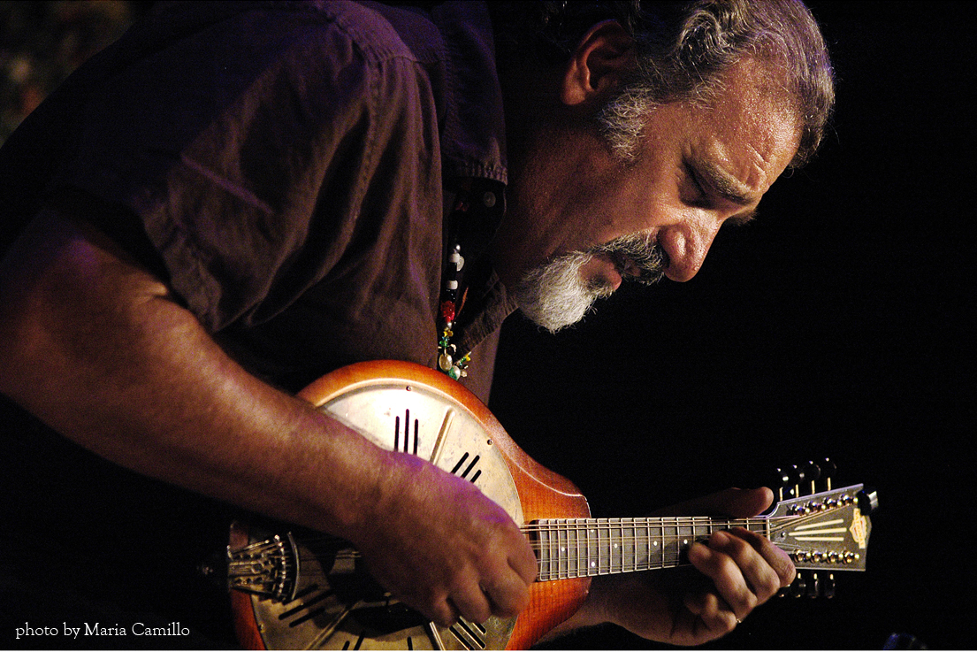

Mandolin player to return to city
By ANTHONY WILSON Special to the Standard-Times
Thursday, January 15, 2009
The mandolin that Rich DelGrosso bought as a souvenir during an Italian vacation more than 40 years ago "changed my life," he says.
In a lot of ways, it has become his life.
Perhaps the foremost practitioner of mandolin blues, DelGrosso is unquestionably the tiny instrument's biggest booster. On Friday night, he returns to San Angelo to cap this year's edition of the Cactus Music Series with a performance that the series' fans demanded.
Earlier in the day, he will conduct a two-hour workshop with Lake View and Central high school music students, during which he will help the students compose and rehearse their own blues composition. The students will later join him onstage at the Cactus Hotel to perform the piece.
DelGrosso, 59, was a high school student himself when, during a trip to Italy to visit distant relatives, he picked up the instrument, which he meant to keep as a memento.
He taught himself to play, growing serious about the instrument when he heard legendary blues mandolinist Johnny Young playing on an Otis Spann record.
"I thought, 'Wow! That sounds so good. I've got to do that,'" DelGrosso recalled.
The blues and the mandolin have since become intertwined passions for the retired teacher.
He writes freelance articles about the instrument for a virtual library of blues magazines.
He also paints - mostly portraits of blues greats.
His Web site, mandolin blues.com, provides a taste of the history of the instrument from his book "Mandolin Blues," including how a young Bill Monroe blended an uncle's favored fiddle music with the blues to create a new genre - bluegrass, with which the mandolin is most closely identified today.
Playing blues on the mandolin "has been done since the blues began," DelGrosso said. However, the acoustic instrument - and its players - were practically put out of business by the electric guitar, which became the blues' standard-bearer.
That may be changing. This year, DelGrosso is one of three mandolinists nominated in the "Instrumentalist: Other" category of the Blues Music Awards. He was the only mandolin player when he earned his first nomination in 2006.
The mandolin's trembling high-pitched voice, along with the texture provided by its double set of strings, helps it stand apart from the cacophony of thousands of wailing blues guitars.
"If someone hears my mandolin, they say, 'Oh, that's DelGrosso,'" he said. "And that's good."
People seem naturally curious about the instrument. DelGrosso has been asked about his "banjo" and his "really small guitar." He is also quizzed about how a big guy like him manages to coax beautiful music from an instrument so small.
"It's all in the fingertips," DelGrosso explained. "I don't have any bigger fingertips than anyone else. It works."
DelGrosso was part of bluesman Pinetop Perkins' backup band during last year's Cactus Music Series. Afterward, fans asked the San Angelo Cultural Affairs Council, which sponsors the series, to bring him back as a featured act.
"People are a little hesitant when they hear 'blues mandolin,'" said Tara Rainey, the cultural affairs council's executive director. "But the moment he got on stage and started playing, that went out the window. It was unmistakably the blues. It was fabulous."
If you go
* What: Cactus Music Series presents "A Night of Blues with Rich DelGrosso," with a special appearance by harmonica player Jimmy "Slim Jim" Rose.
* When: 8 p.m. Friday.
* Where: Cactus Hotel, 36 E. Twohig Ave.
* Tickets: $20 general admission, $10 for military and students with IDs. Available at San Angelo Cultural Affairs Council, Suite 200 in Cactus Hotel; Blair's Western Wear, 4230 Sherwood Way; Goodfellow Air Force Base Events Center; at the door; or by calling (325) 653-6793.
* What else: Only 300 tickets are available. Dress is as casual or dressy as you like. A cash bar will be open.

